Patient Portal Help file
https://ehr.empowerdrs.com/premiersurgicalportal
Prerequisite
Please use Internet explorer 9 and Above
- Please do the following setting before registration
- click on tools->options on your internet explorer.
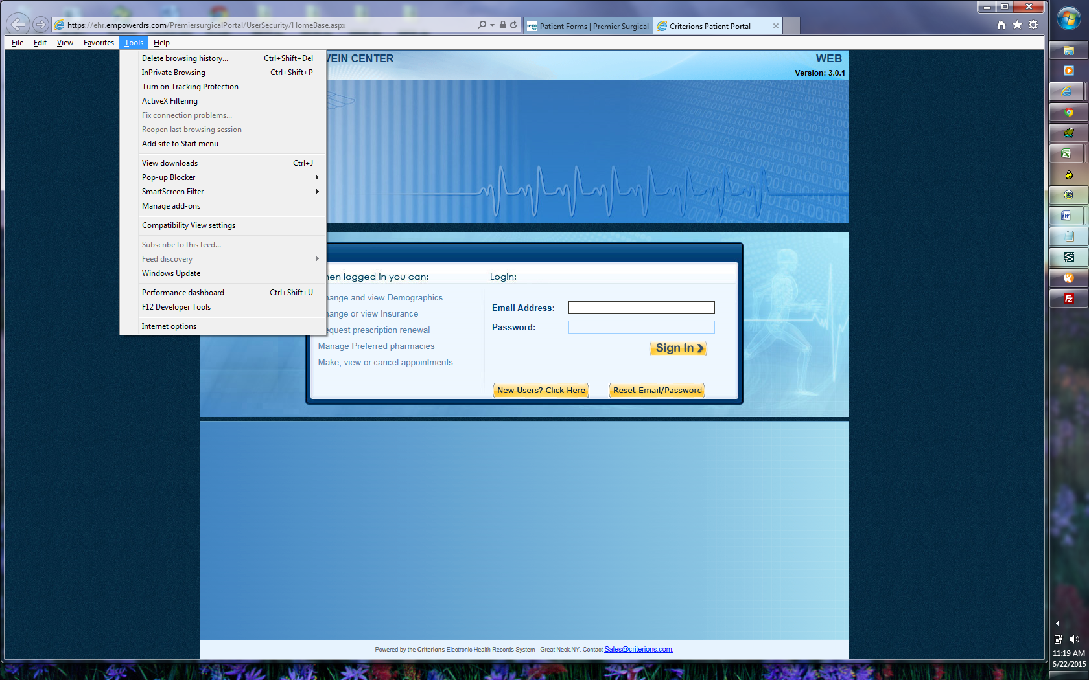

- click on Compatibility view settings
- You should notice “empowerdrs.com” and Add button to the right. Click on ADD.

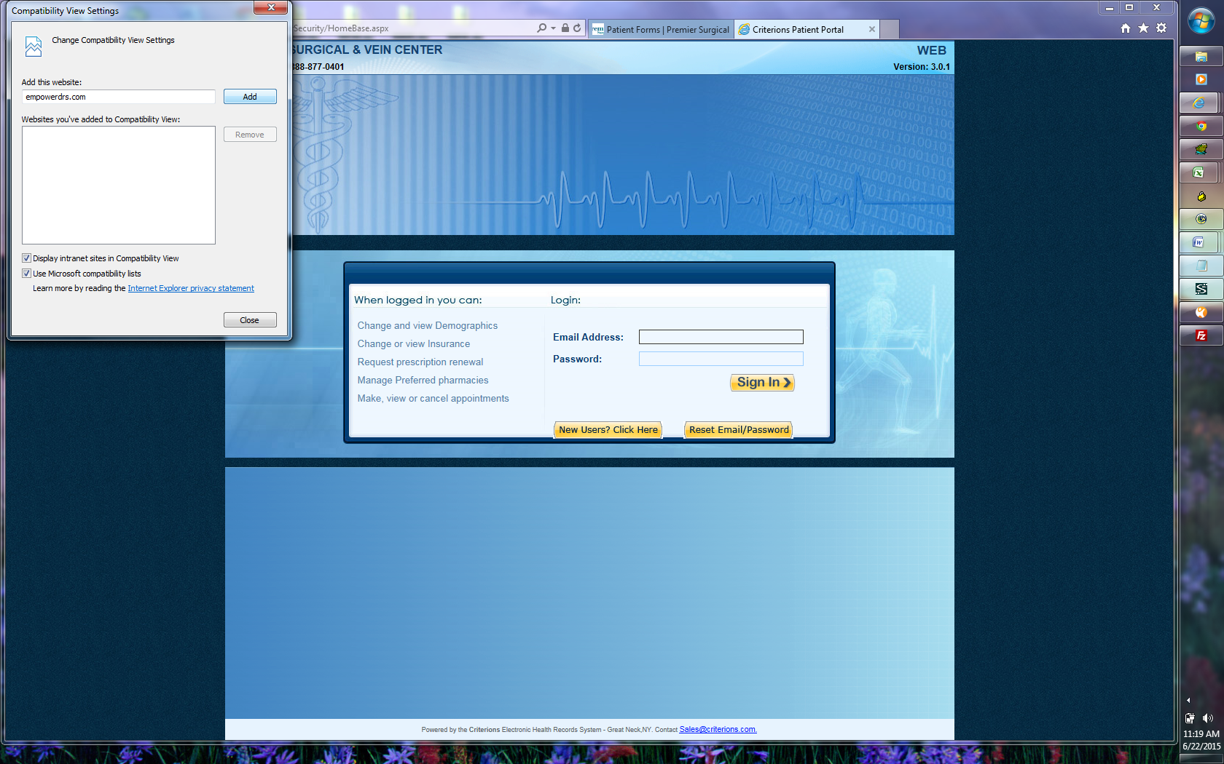

- You should notice “empowerdrs.com” in the bottom window “websites you’ve added to compatibility view”
- Click on close

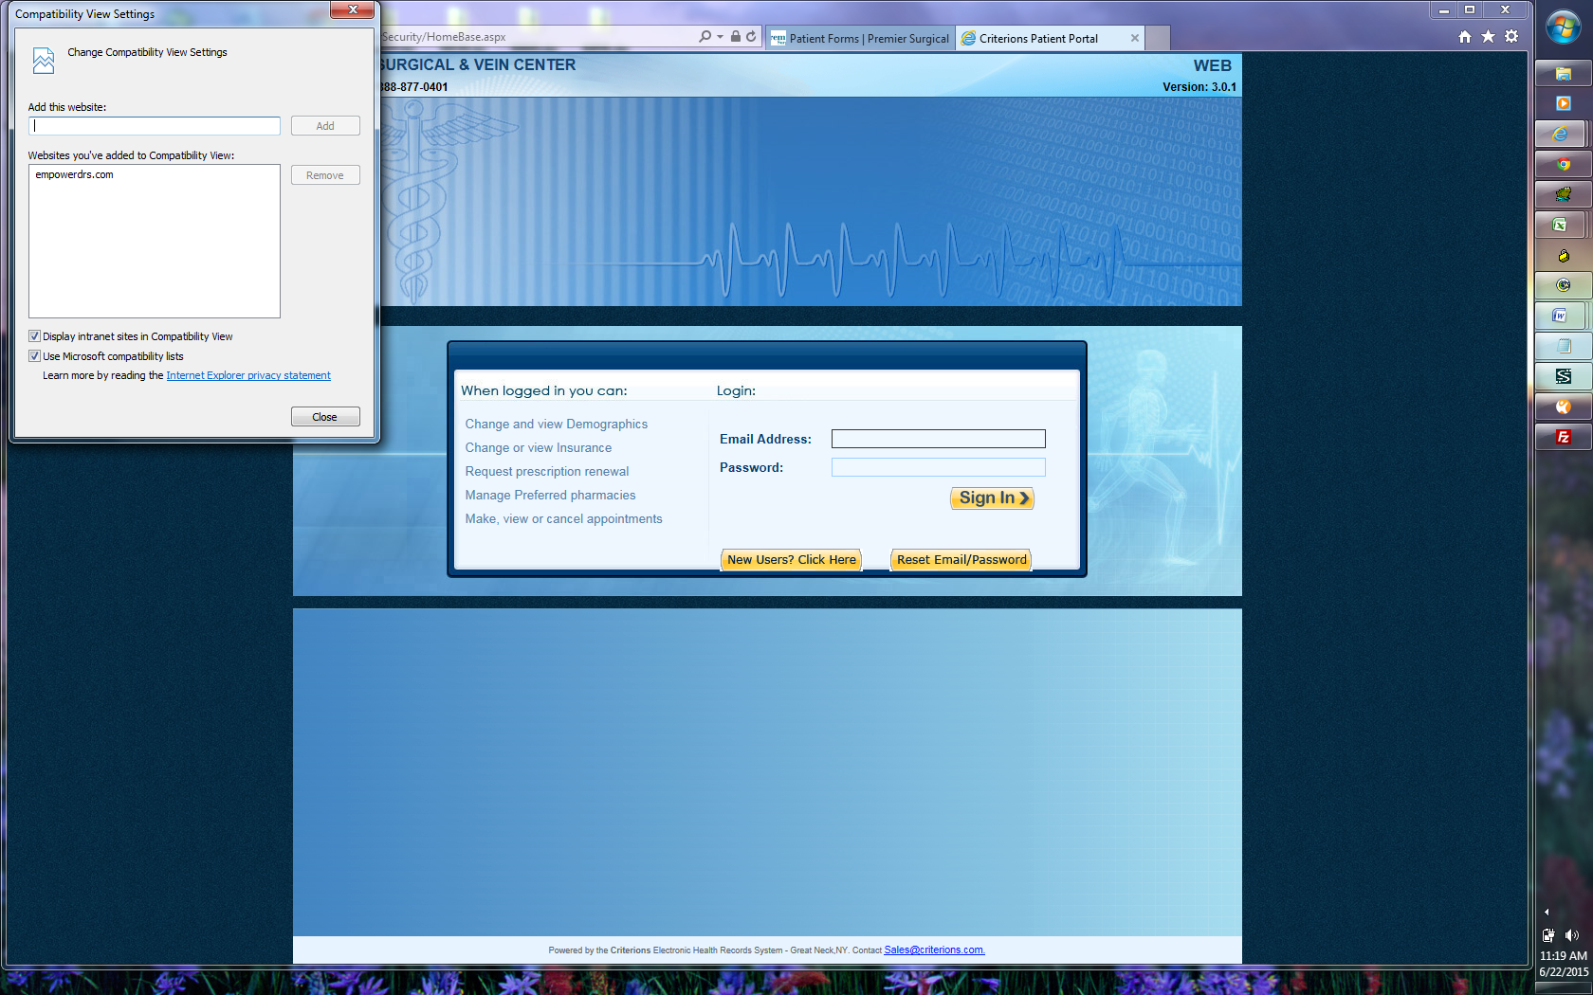

To Register Click new user.
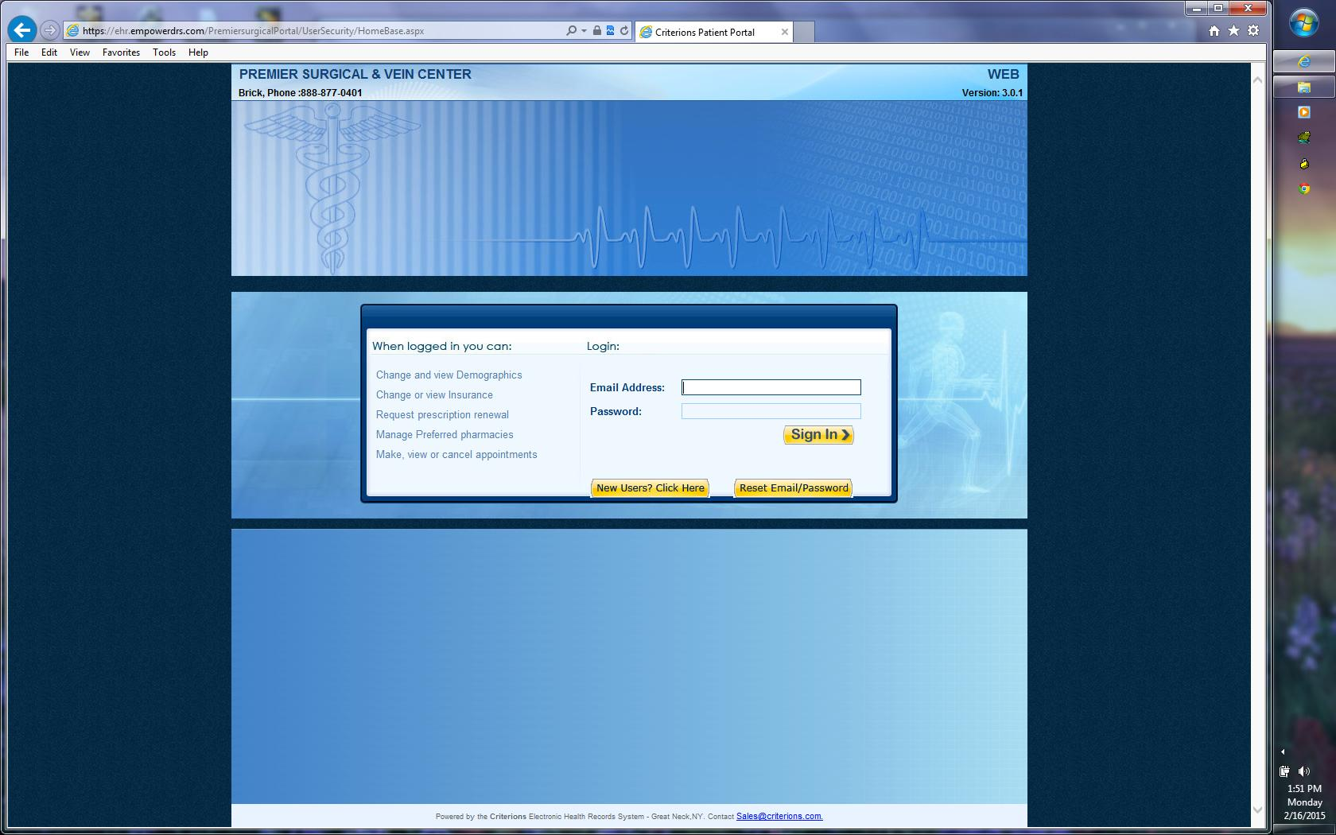
Enter last name , firstname , last 4 digit ssn, DOB , Phone and email address. Please make sure the information matches the data on file . If you are not able to register please call office to verify the information on file
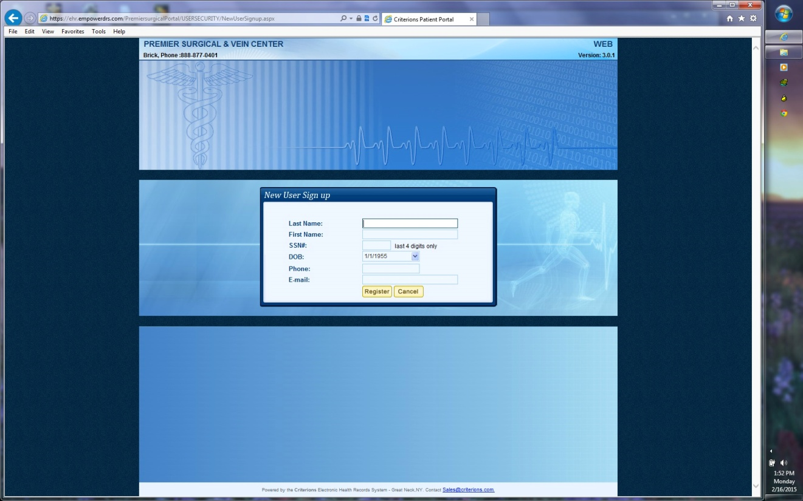

After you register, you should receive a confirmation email from patient.portal@gmail.com
Dear Lastname, Firstname,
Thank you for registering with our Patient Portal, your medical access point. Our Patient Portal allows you to view and update your contact and insurance information, schedule and cancel appointments, renew prescriptions and more!

Patient Portal Access : https://ehr.empowerdrs.com/premiersurgicalportal
USERNAME : email address
PASSWORD(Case Sensitive):pwd

To change your password simply login to PATIENT PORTAL and click Change Password.
Click on the link . “https://ehr.empowerdrs.com/premiersurgicalportal “

Enter the user/pwd and click on sign in..
The home page has a summary of your profile.
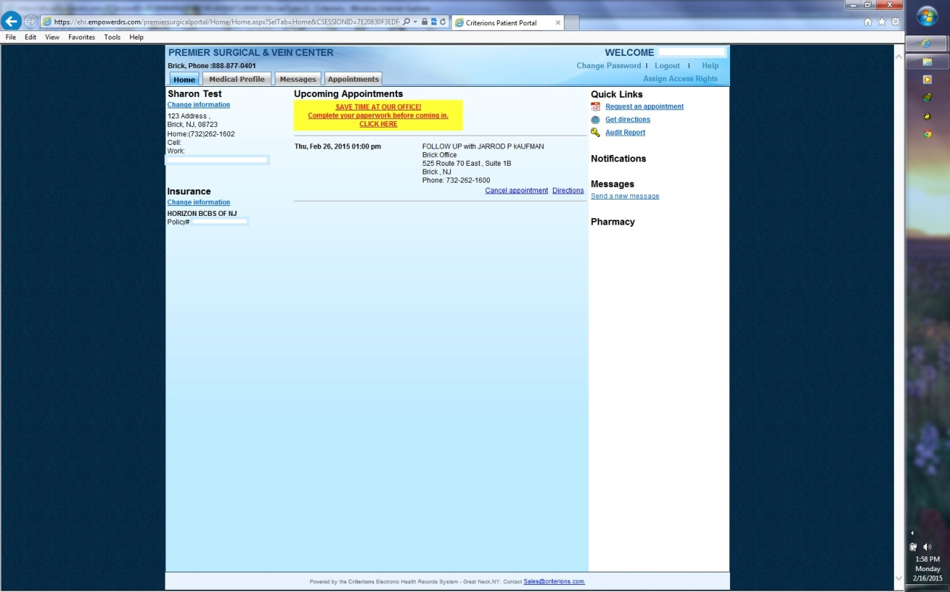

Click on Medical Profile.
Review your demographics and if it is incorrect . click on No and enter the information.
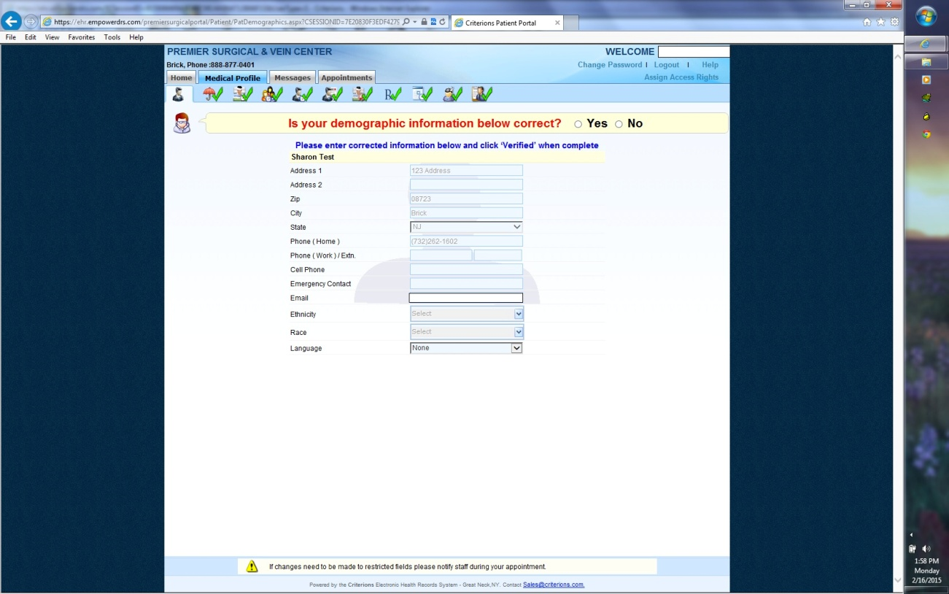
Click on save to go to the next tab . review your insurance and update if the information is incorrect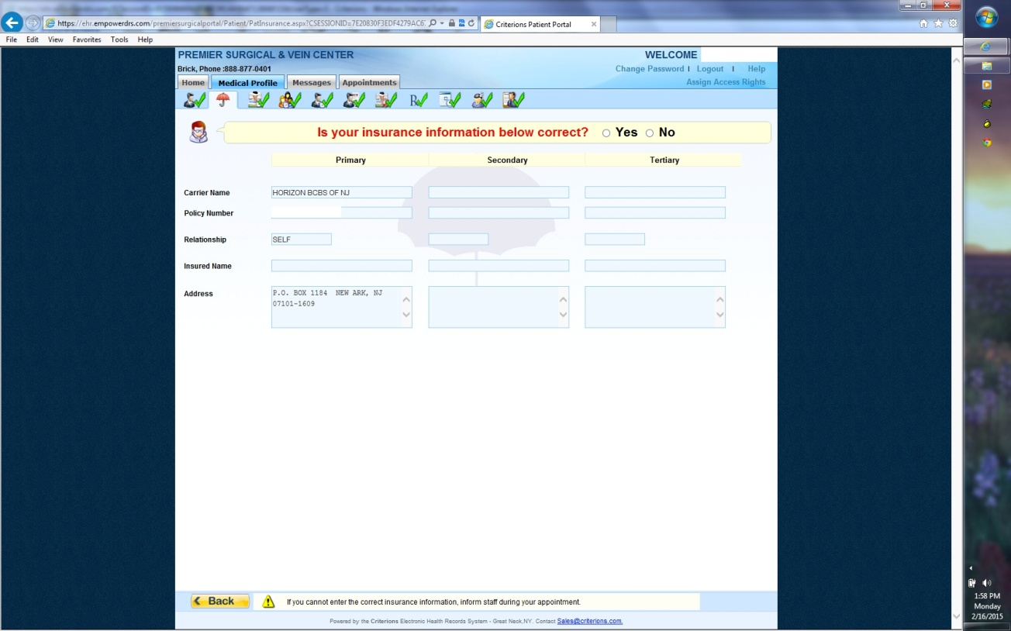
Click on save to go to the next tab . review your PMH and update if the information is incorrect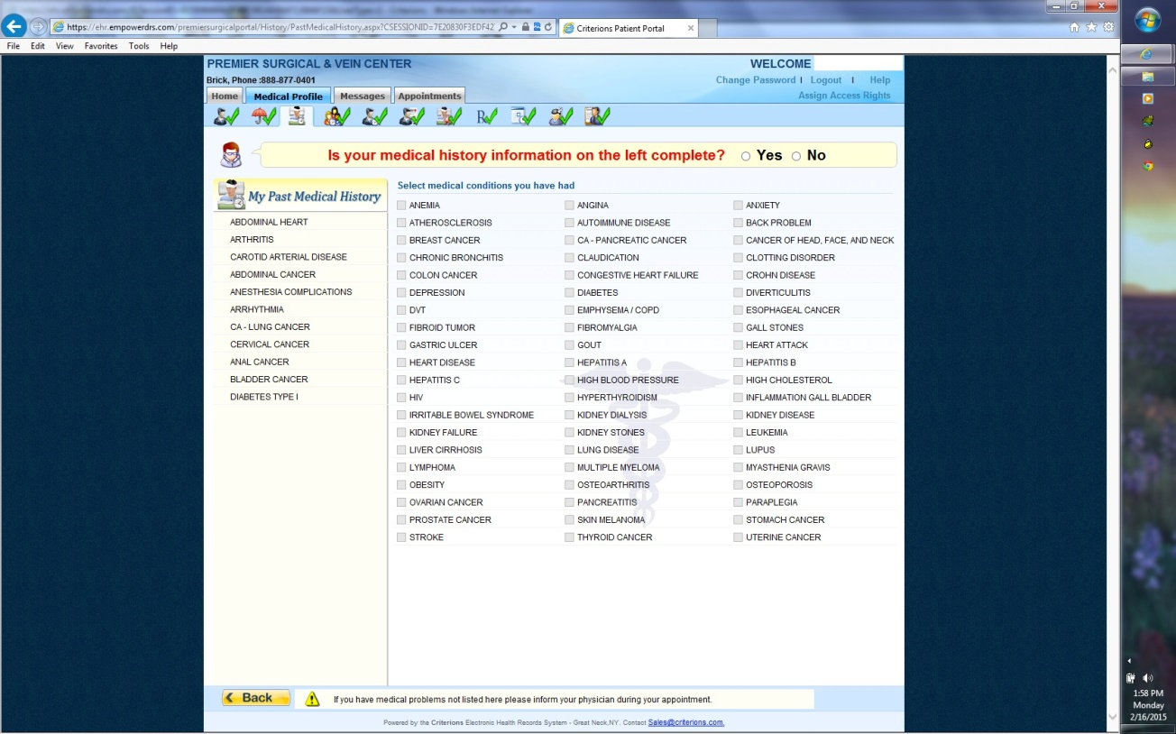
Click on save to go to the next tab . review your FMH and update if the information is incorrect
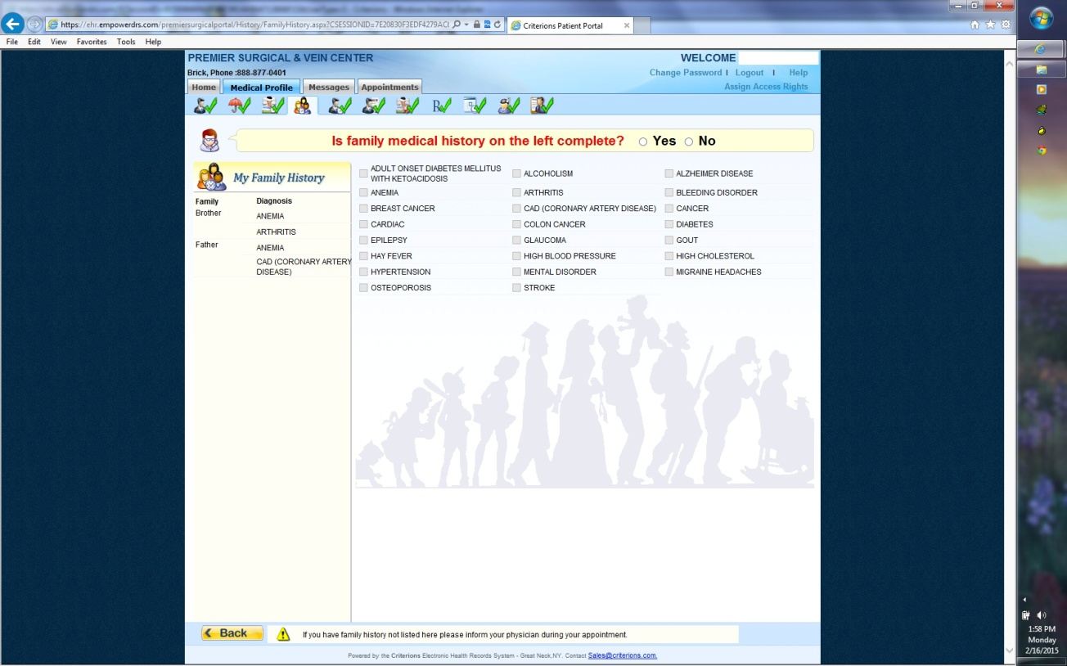
Click on save to go to the next tab . review your Social history and update if the information is incorrect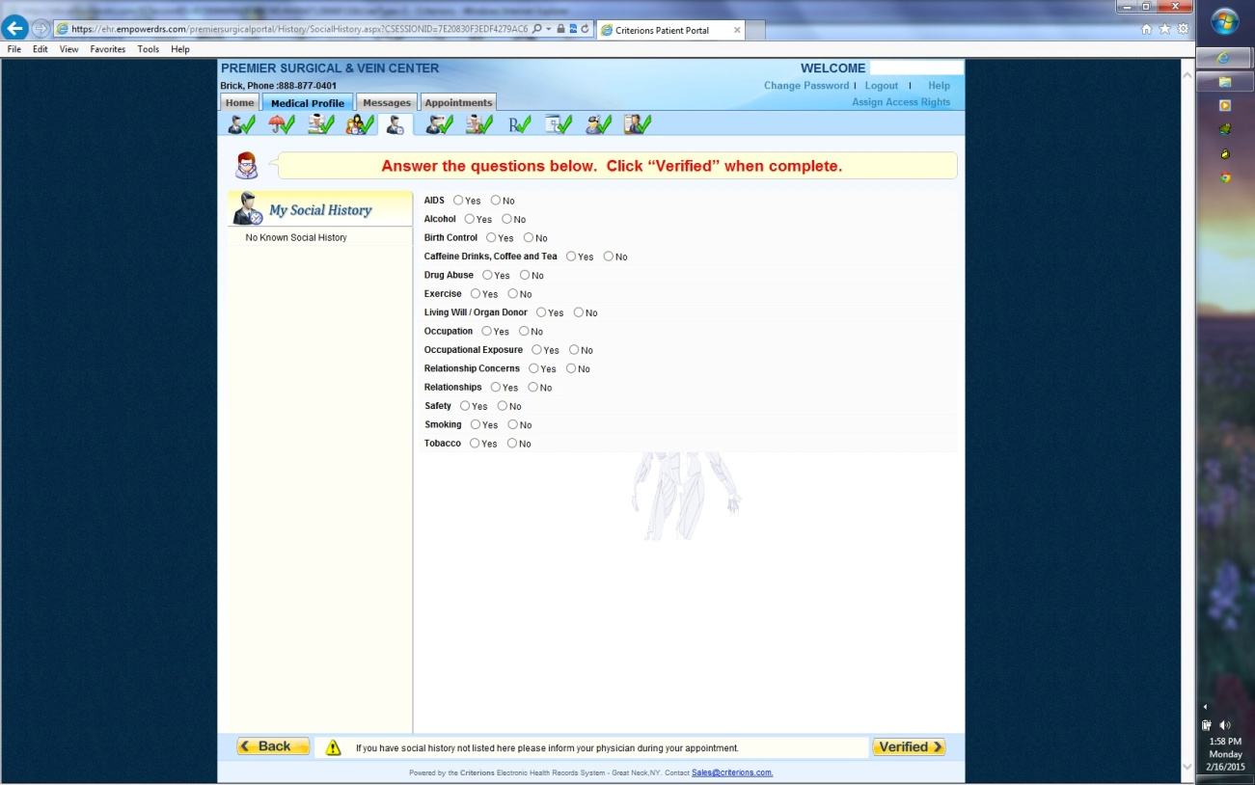

Click on save to go to the next tab . review your Medication and update if the information is incorrect
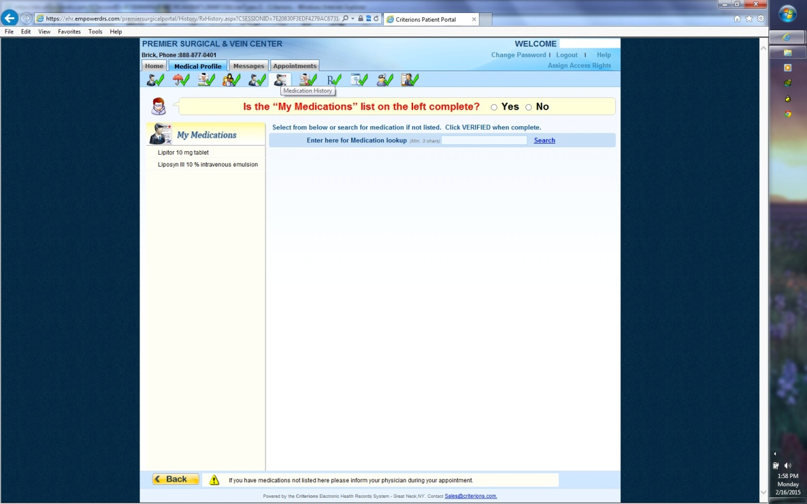
Click on save to go to the next tab . review your Allergies and update if the information is incorrect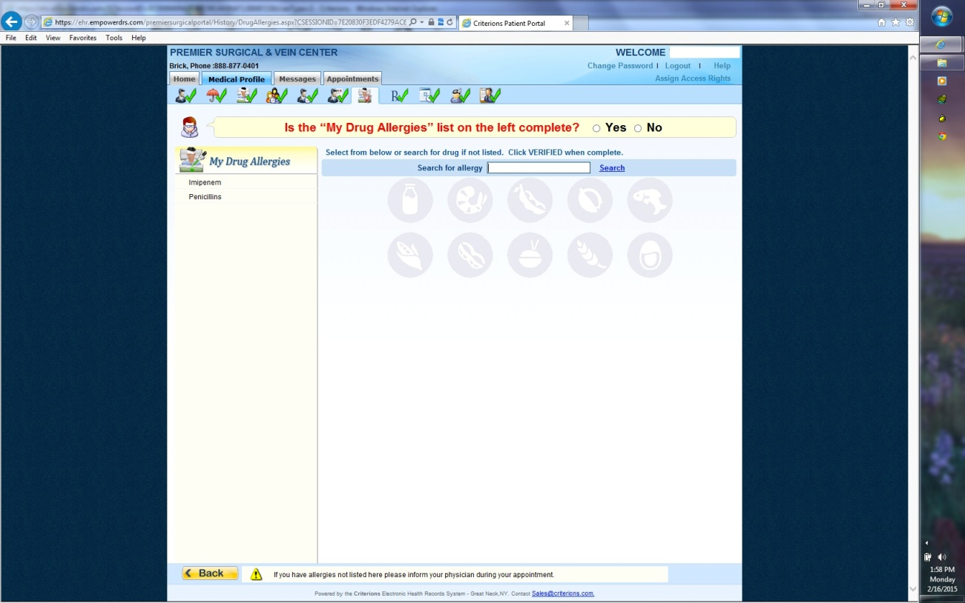
Click on save to go to the next tab .
You can schedule appointments by selecting the provision , appointment reason and location ..
On the right side you can select the date and available timeslots.. 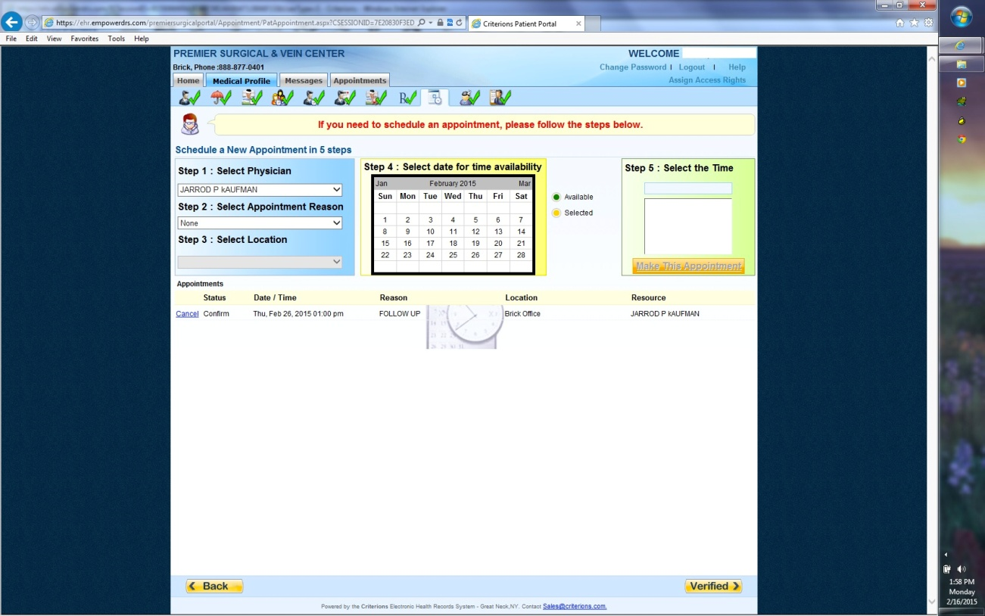
Click on save to go to the next tab . you can fill in your chief complaint ‘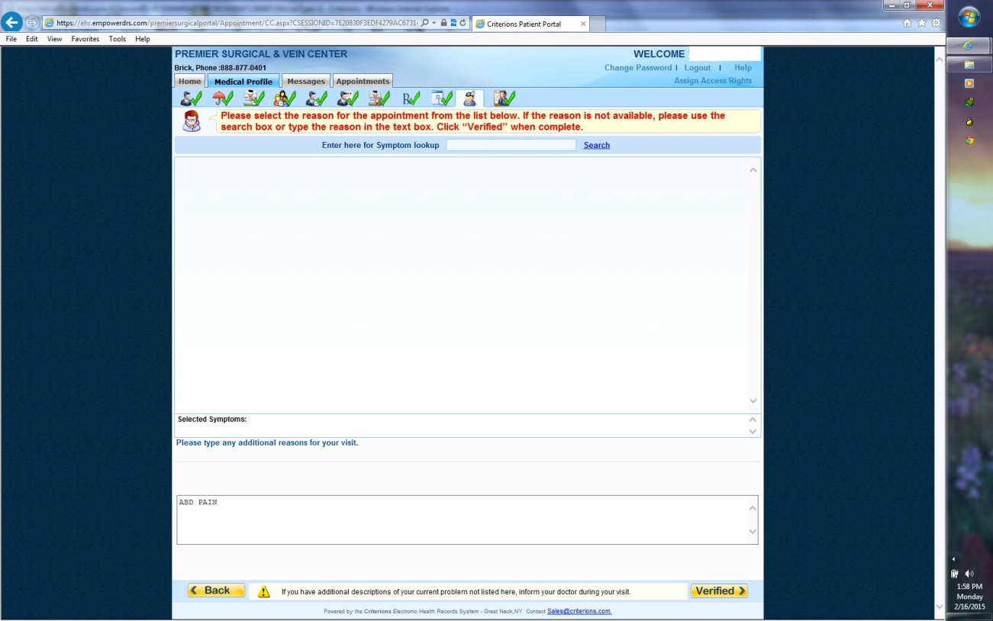

Click on save to go to the next tab . you can fill in your Review of systems. Questionnaire 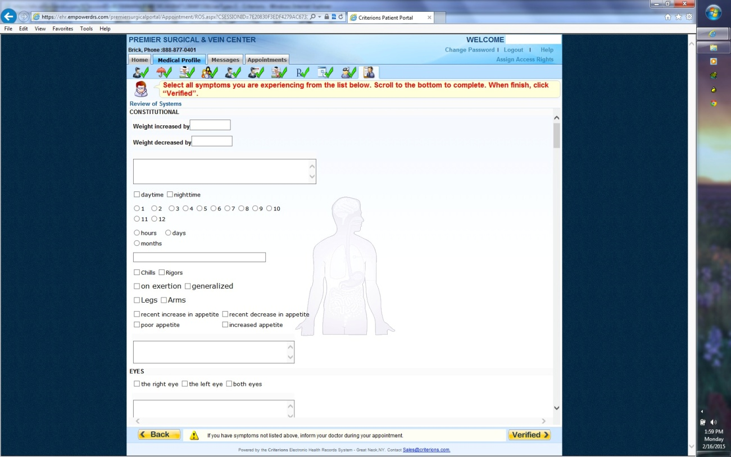And click on save…

